Payer Mapping Tool
User Guide
Version 5.0 — March 2026

Table of Contents
- 1. Overview
- 2. Getting Started
- 3. Step 1: Strip PHI from Your Placement File
- 4. Step 2: Connect to Your Client
- 5. Step 3: Upload Files
- 6. Step 4: Map Payers
- 7. Step 5: Export Your Work
- 8. Special Payer Options
- 9. Tips & Troubleshooting
- 10. PHI & Security

1. Overview
The Payer Mapping Tool helps operations staff map placement file plans to their corresponding Availity payer names or portal destinations. This mapping is used to generate configuration files for UiPath automation.
The typical weekly workflow is:
- Strip PHI from your raw placement file using the PHI Stripper tool
- Connect to your client account in the Payer Mapping Tool
- Upload the clean placement summary file
- Map each plan to its Availity payer or portal
- Save your mapping progress (Excel backup)
- Export the UiPath JSON file for automation
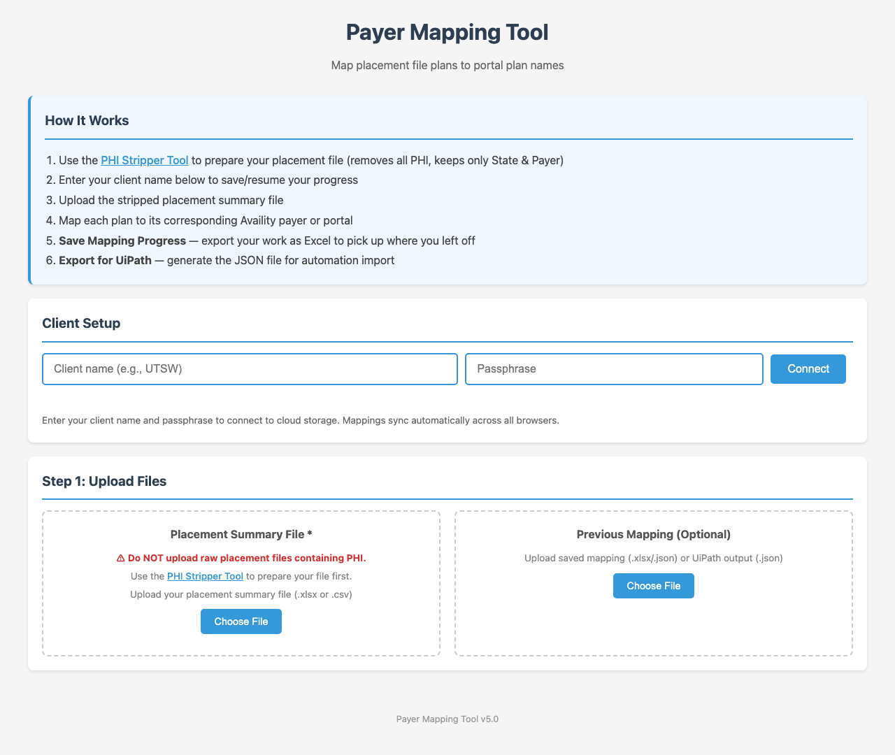

2. Getting Started
Access the tool at:
https://kellmat74.github.io/data_mapping/
Requirements:
- Modern web browser (Chrome, Edge, or Firefox recommended)
- Internet connection (for cloud sync)
- Your client name and passphrase (provided by your admin)
- A placement file that has been processed through the PHI Stripper

3. Step 1: Strip PHI from Your Placement File
IMPORTANT: Never upload a raw placement file containing PHI to the Payer Mapping Tool. Always use the PHI Stripper first.

The PHI Stripper is a separate tool that removes all personal health information from your placement file, keeping only the State and Payer columns needed for mapping.
Access the PHI Stripper at:
https://kellmat74.github.io/data_mapping/phi_stripper.html
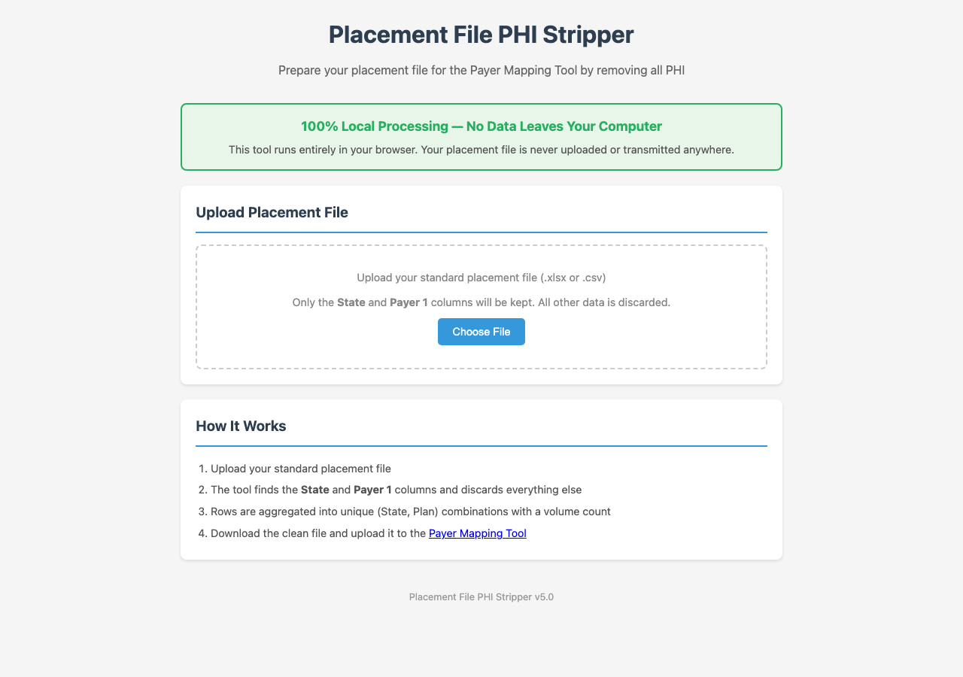

How to use the PHI Stripper:
1. Open the PHI Stripper tool in your browser
2. Click "Choose File" and select your raw placement file (.xlsx or .csv)
3. The tool will process the file locally — no data leaves your computer
4. Review the summary showing original vs. output statistics
5. Click "Download Clean File (.xlsx)" to save the stripped file
6. The clean file will be named "[YourFileName]_clean.xlsx"
Privacy Note: The PHI Stripper runs 100% in your browser. Your placement file is never uploaded or transmitted anywhere. All processing happens locally on your computer.

4. Step 2: Connect to Your Client
After opening the Payer Mapping Tool, connect to your client account:
1. Enter your client name (e.g., "UTSW") in the Client Name field
2. Enter your passphrase in the Passphrase field
3. Click "Connect"

After connecting, you will see one of these status messages:
Status | Meaning
☁️ Connected — Loaded X mappings | Existing client with saved mappings in cloud
☁️ Connected — New client | First time using this client name
💾 Local only | Could not connect to cloud; working offline

Tip: Use the exact same client name each time. Mappings sync automatically across all browsers when connected to the cloud.

5. Step 3: Upload Files

Placement Summary File (Required)
Upload the clean file you created with the PHI Stripper:
1. Click "Choose File" under "Placement Summary File"
2. Select your _clean.xlsx file
3. The tool will analyze the file and display all unique plans grouped by state
If you accidentally upload a raw placement file with PHI columns, the tool will reject it and ask you to use the PHI Stripper first.

Previous Mapping (Optional)
If you have a saved mapping file from a previous session, upload it to pre-populate your mappings:
1. Click "Choose File" under "Previous Mapping (Optional)"
2. Select one of these file types:
- Saved mapping progress (.xlsx) — from the "Save Mapping Progress" button
- UiPath output (.json) — from the "Export for UiPath" button

6. Step 4: Map Payers
After uploading your placement file, the mapping interface appears with plans organized by state.
For each plan:
1. Find the plan in the list (use the search box to filter by name)
2. Click the dropdown next to the plan name
3. Select the appropriate Availity payer from the list
4. Your selection is saved automatically

Visual Indicators
Row Color | Meaning
Green | Mapped to an Availity payer
Orange | Mapped to a non-Availity portal (UHC, Cigna, etc.) or "Not In Availity"
White | Not yet mapped

Filters & Search
Use these tools to focus your work:
- All — Shows all plans
- Unmapped Only — Shows only plans you haven't mapped yet
- Mapped Only — Shows completed mappings
- Search box — Type to filter plans by name

Progress Statistics
The Mapping Progress section shows:
- Total Plans — Number of unique plan + state combinations
- Mapped — How many you've completed
- Unmapped — How many still need mapping
- States — Number of different states in your file
- Progress bar — Visual percentage of completion

7. Step 5: Export Your Work

Save Mapping Progress (Recommended)
Click "Save Mapping Progress" to download your current mappings as an Excel file. This file can be re-imported later using the "Previous Mapping" upload if needed.
File name: payer_mapping_[ClientName].xlsx

Export for UiPath (Required for Automation)
When you've finished mapping, click the green "Export for UiPath (.json)" button. This generates the JSON configuration file your automation team needs.
File name: [ClientName]_uipath.json
Note: Plans mapped to non-Availity portals (UHC, Cigna, HPN, etc.) and "Not In Availity" are automatically excluded from the UiPath export — only Availity-mapped plans are included.

8. Special Payer Options
At the top of each payer dropdown, you'll find these special options:
Option | When to Use
Not In Availity | Payer is not available in Availity and cannot be processed through any portal
Cigna Portal | Payer should be processed through the Cigna portal
HPN Portal | Payer should be processed through the HPN portal
OptumCare Portal | Payer should be processed through the OptumCare portal
Superior Portal | Payer should be processed through the Superior portal
UHC Portal | Payer should be processed through the UHC portal
UMR Portal | Payer should be processed through the UMR portal

Important: Plans mapped to these special options are excluded from the UiPath JSON export. They appear with an orange background in the mapping interface.

9. Tips & Troubleshooting

Common Questions
Q: Why did my file get rejected?
A: The tool rejected your file because it detected PHI columns (e.g., PatientFirstName, DOB, MemberID). Use the PHI Stripper tool first to remove all PHI, then upload the clean file.

Q: Why are my previous mappings not showing?
A: Plan names must match exactly between the placement file and the mapping file. If your placement file has different plan names than your saved mapping, they won't auto-match.

Q: Can I work offline?
A: Yes. If you can't connect to the cloud, the tool falls back to local browser storage. Your mappings will sync to the cloud next time you connect.

Q: What browsers are supported?
A: Chrome, Edge, and Firefox are recommended. Safari may work but is not fully tested.

Q: Why do I see the same plan in multiple states?
A: Each state may have different Availity payer options. The same plan name in Texas might map to a different Availity ID than in California.

10. PHI & Security
- The PHI Stripper runs 100% locally in your browser — no data is transmitted
- The Payer Mapping Tool stores only plan names and payer mappings in the cloud — no patient data
- Raw placement files with PHI columns are automatically rejected by the mapping tool
- All file processing (reading spreadsheets, generating exports) happens in your browser
- Cloud storage (Firebase) contains only: client name, payer mappings, and timestamps
- Your passphrase is hashed before comparison — it is never stored in plain text

Remember: Always use the PHI Stripper before uploading any placement file to the Payer Mapping Tool.

Payer Mapping Tool v5.0 — User Guide

